The publish version in IIS, needs these folders:
- Font
- Icons
- TempInvoices -> (this contains a folder inside called TxtTemplates (it contains an important .txt file called topasianinv.txt).
Note: TempInvoices: works for now as the output for the .pdf and .txt files, until a new input field is added to the prtinv1.html (or any other .html), then I will read the output path from there.
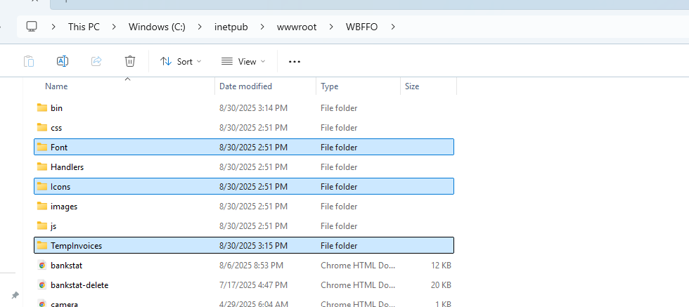
Inside the js folder, there’s a new file called topasiainv.js.
Note: I’m reading the invno and the uuid, from prtinv1.html input values.
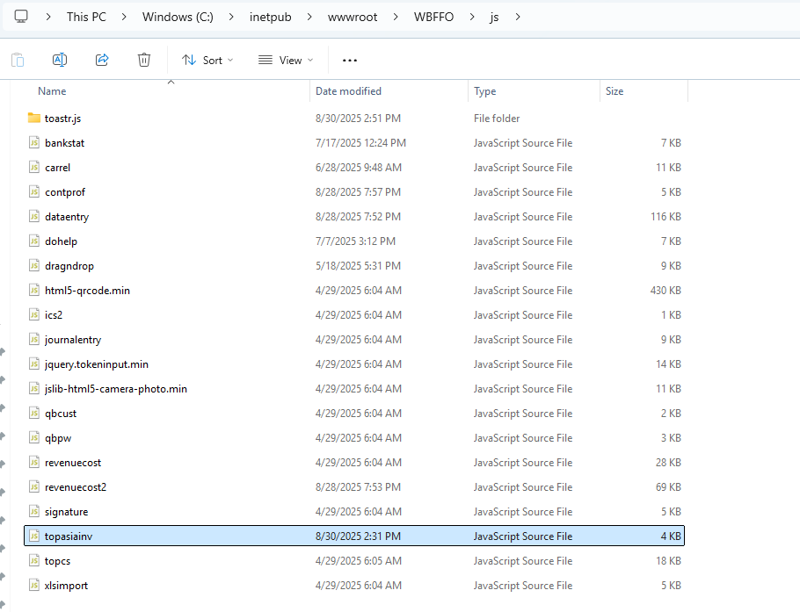
In the main folder are one new file topasiainv.ashx, and the prtinv1.html (that includes the onClick="createInvoice()"):
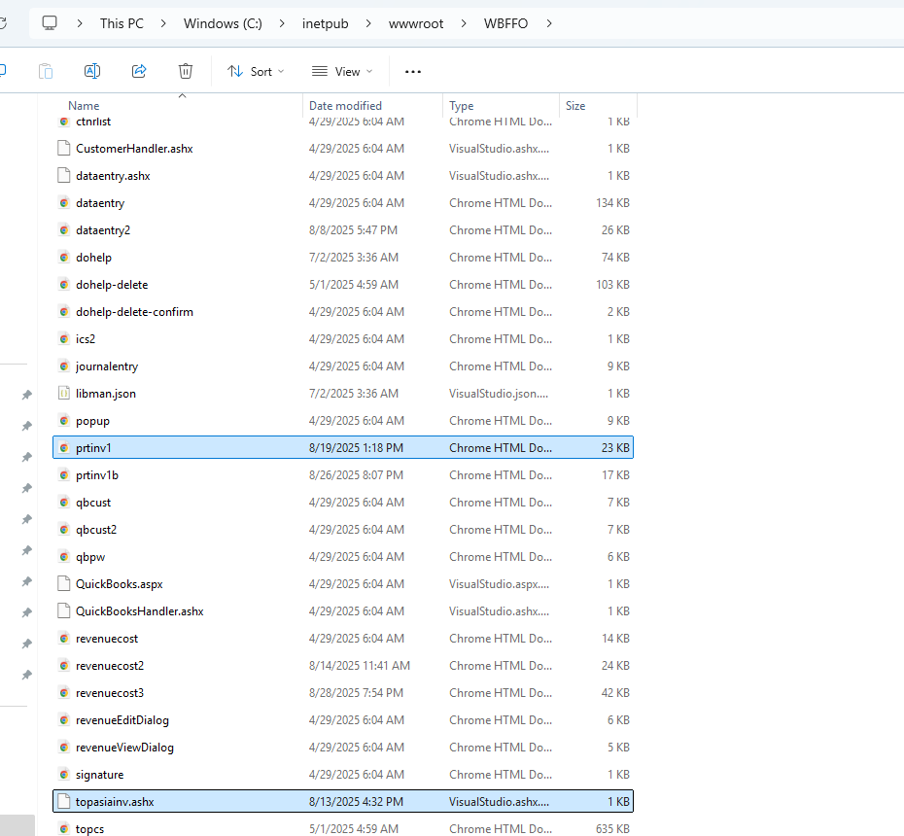

Under the bin folder couple of folders and files are needed:
- de -> Folder
- Humanizer.dll
- PdfSharpCore.dll
- Scriban.dll

Extra information
I’m not hardcoding this data. It is pulling it from the prtinv1.html
UUID: 00D1B295-8D61-4435-B3B9-87AA82C192AE
HBL: SHAP80021 (except this data, that’s only present in the PDF I think)
Invoice No.: SGS25080004
Invoice Print Currency: RMB

Locally: inside the dataentry.csproj multiple references are needed.
Scriban -> Nuget Package
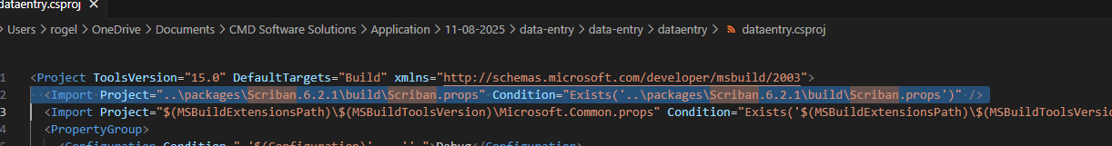
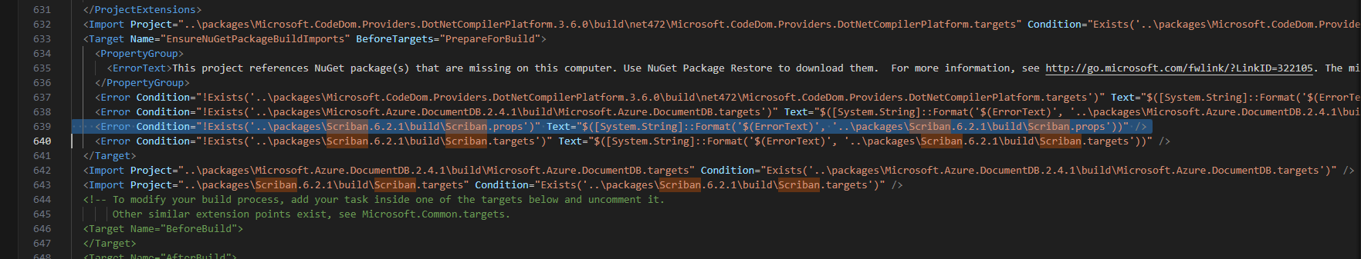
Note: The Scriban Nuget Package Contains multiple other folders. They are not reflected in the Publish-> Relase\bin folder, but just in case here the Scriban folder contains:
Inside the lib\netstandard2.0\ Scriban.dll (which I believe that the Publish -> Release\bin Scriban.dll contains all these files).
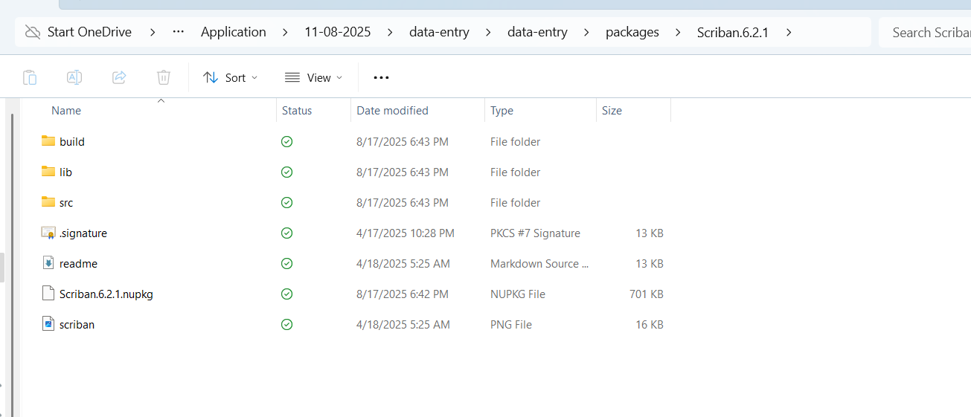
PdfSharpCore -> Nuget Package
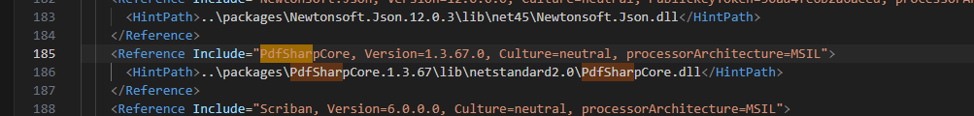
Humanizer -> Nuget Package

Folders added:
- Font
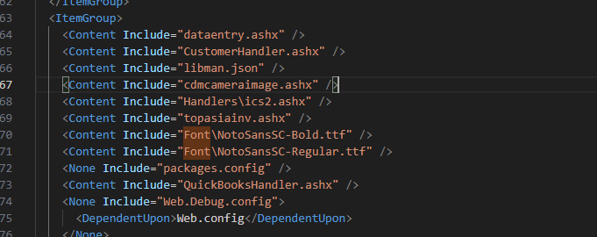
- Icons
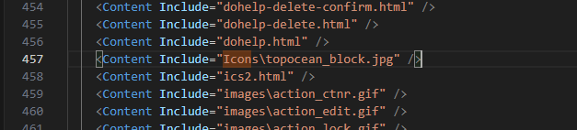
- TempInvoices
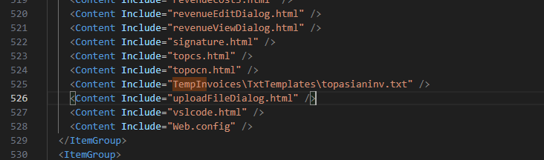

In the .rar I’m adding the dataentry.csproj in case you want to copy all the above lines, and create a publish version from your current local .sln.
Also, I’m including the Scriban folder for local environment. It is the .rar under:
local\ packages\Scriban.6.2.1

